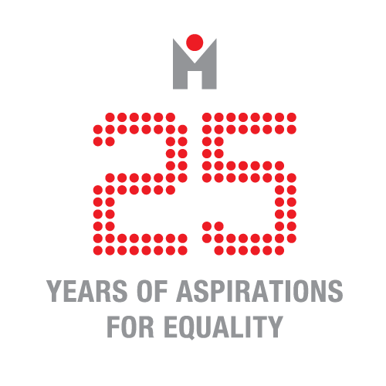

Ljubljana, March 10

Invitation & press release

Debates on prostitution and sex work in Ljubljana

The European network ProsPol ‘Comparing European Prostitution Policies: Understanding Scales and Cultures of Governance’ (www.prospol.eu) will hold its sixth meeting in Ljubljana, Slovenia, on March 21st -23rd 2016, organized by the Peace Institute. The aim of ProsPol is to exchange, enhance and compare knowledge about prostitution policies across Europe. ProsPol began its activities in 2013 and will continue to provide an innovative platform of exchange to enhance understanding on prostitution policies until 2017. The network, chaired by Dr Isabel Crowhurst, University of Essex, is funded by the European intergovernmental body COST and the University of Essex is the Grant Holding institution.

We look forward to holding our meeting in Slovenia and to facilitating more conversations and improved understandings on prostitution policies and the contexts and organisations of sex work in a country that remains relatively invisible in international discussions on these issues. The Slovenian partner, member of ProsPol Dr Mojca Pajnik together with MSc Mojca Frelih and Dr Iztok Šori will be hosting the meeting, as well as a number of open events aimed at stimulating public debates on prostitution and its governance.

On Monday 21st March (2.30-6.30 pm) an open session on sex work and public health will be held at the Association of Free Trade Unions of Slovenia (Zveza svobodnih sindikatov Slovenije), Dalmatinova ulica 4, Ljubljana, 6th floor with invited keynotes by: Dr Gillian Abel, University of Otago, New Zealand, Dr Lucy Platt, London School of Hygiene and Tropical Medicine, UK, and Dr Agata Dziuban, Jagiellonian University, Poland and ICRSE.

On Wednesday 23rd March (10-12 am) a discussion on prostitution and sex work in Central and Eastern Europe and the Balkans organized by the Peace Institute (http://www.mirovni-institut.si/) and ICRSE, International Committee on the Rights of Sex Workers in Europe (http://www.sexworkeurope.org) will be held at Pritličje, Mestni trg 2, Ljubljana with the following speakers: Boglárka Fedorkó, Communications Officer of the Hungarian Association of Sex Workers (SZEXE), Roxana Vasi, sex worker and also working with Sex Workers' Rights Advocacy Network (SWAN), Agata Dziuban, Jagiellonian University in Poland, ICRSE and Association Program STACJA, Mario Knezevic, acting manager of NGO Sloboda prava, Equal Rights from Serbia and Roman Kuhar, Faculty of Arts, University of Ljubljana and Legebitra.

The round table will be moderated by Mojca Pajnik from the Peace Institute and Luca Stevenson, sex worker and coordinator at ICRSE and will be opened by Metka Naglič from Amnesty International Slovenia.

At Pritličje we will display works by the artist Tadej Pogačar, founder of P.A.R.A.S.I.T.E. Museum of Contemporary Art (http://www.parasite-pogacar.si/) on the subject of sex work and precarious economies. The exhibition entitled CODE:RED Publicité was prepared by Tadej for this very occasion. It will remain open until 17th April.

We also invite the interested public to follow Sex Workers Speak: Who Listens? series on Beyond Trafficking and Slavery, OpenDemocracy, guest edited by ProsPol members Giulia Garofalo Geymonat and PG Macioti live at https://www.opendemocracy.net/beyondslavery

Monday and Wednesday discussions are open to the public. The same goes for CODE:RED Publicité exhibition.

For easier organization please confirm your attendance (by 18th March) at: mojca.frelih@mirovni-institut.si
When confirming, please indicate the events of your interest.

YOU ARE KINDLY INVITED TO ATTEND THE OPEN EVENTS!

