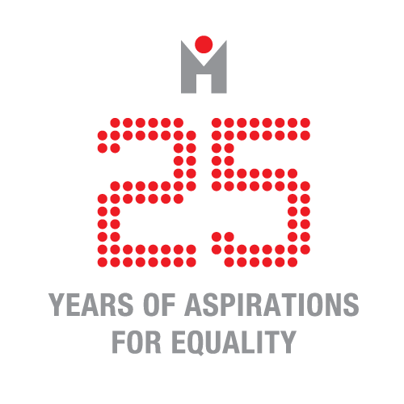

Mednarodno srečanje ‘Comparing European Prostitution Policies: Understanding Scales and Cultures of Governance’

Ljubljana, 21.-23. marec 2016
Zveza svobodnih sindikatov Slovenije, Dalmatinova ulica 4, 6. nadstropje

Povzetki javnih predavanj na temo seksualnega dela in javnega zdravja
21. marec ob 14.30

Gillian Abel

‘From harm minimisation to social justice: a public health perspective on decriminalisation of sex work in New Zealand’

The foundation principle of Public Health is social justice. People working within this discipline aim to address societal conditions so that people can live heathier lives. Most public health research into sex work, however, has focused on harm minimisation, concentrating on sex workers’ sexual health, seeing this as the main risk to sex workers’ health. There is little research into the conditions of sex work and how policies that criminalise their activities create conditions where exploitation, coercion and violence can thrive. There is no access to justice for criminalised sex workers because to do so would mean exposing themselves to repercussions which could see them pursued by justice themselves. This creates inequities in the experience of well-being between sex workers and people engaged in other forms of service work.

One of the aims of public health is to create healthy public policy. To change policy you do need evidence to show that the existing policy is not working and to also provide support for an alternative approach. The public health research carried out in New Zealand has achieved this through working in partnership with New Zealand Prostitutes Collective (NZPC). The sex workers voice has featured strongly in the research and also in the formation of the current legislation in New Zealand. Sex work in this country is decriminalised and undoubtedly the main achievement of this has been the attainment of human rights for sex workers.

Short bio
Gillian Abel is an Associate Professor and Head of Department in the Department of Population Health, University of Otago, Christchurch, New Zealand. Her research expertise is in community-based participatory approaches. Her most extensive research work has been in the field of sex work which is decriminalised in New Zealand. Her exploration of how decriminalisation has impacted on the health, safety and human rights of sex workers has been influential in informing policy in New Zealand.

Lucy Platt

‘The health impacts of criminalisation’

A rich body of social science, epidemiological and ‘grey’ literature documents the health harms of criminalisation of sex work. Available epidemiological data consistently associate criminalisation of sex work with increased risk of violence and HIV/STIs, and reduced access to health care, but are limited to a small number of settings. Mathematical modelling of data from Canada, India and Kenya estimates that decriminalisation could reduce HIV incidence by 46% among sex workers and their clients over 10 years. A more geographically extensive qualitative literature illustrates how punitive laws impact directly on sex workers’ capacity for risk reduction, for example through confiscation of condoms, as well as by reproducing other social and systemic factors linked to poor health and disenfranchisement. Police raids on indoor venues, for example, discourage collective working and disrupt access to outreach; displacement drives sex workers into isolated and unsafe workplaces; and fear of discrimination or deportation deter reporting of violence to police. Studies in Canada and Sweden indicate that these harms are reinforced by criminalising sex workers’ clients, whereas data from New Zealand demonstrate that sex workers in decriminalised contexts experience improved access to health/social care and justice. Decriminalisation of sex work is likely to be critical to improving sex workers’ health, access to care and citizenship rights. In the context of scarce statistics, there remains an urgent need for multidisciplinary evaluative research to document context-specific impacts of legislative models on sex workers' health and well-being and to use findings to advocate for evidence-based policies that protects safety and rights.

In this presentation I will present emerging findings from a literature review conducted in collaboration with Pippa Grenfell that synthesises this rich body of social science, epidemiological and community literature documenting the health harms of sex work. I will focus on evidence that summarises: (i) associations between (de)criminalisation and sex workers health; and (ii) the pathways through which these effects occur, including in interaction with other social and systemic factors, such as stigma, housing and collectivisation. I’ll then present some examples of community-based public health interventions both working within the constraints of a criminalised framework as well as those that focus on changing police practices; and thirdly given an example of how certain legislative frameworks have undermined public health approaches. Finally, I’ll discuss some of the challenges, and propose what we see as the priorities, for policy, practice and public health research in this area.

Short bio
I am a Senior Lecturer in Public Health Epidemiology in the Faculty of Public Health and Policy at the London School of Hygiene and Tropical Medicine. My research focusses on examining how social and health policies and interventions influence people who sell sex and/or inject drugs’ vulnerability to blood-borne viruses, sexually transmitted infections (STI) and other health harms. Although primarily an epidemiologist, much of my research draws on mixed-methods, incorporating qualitative methods to develop structured indicators and understand the complex social processes that drive individuals’ behaviour as well as collaborating closely with mathematic modellers to simulate intervention impact on disease transmission. I am currently leading a large multi-collaborator project pooling existing surveillance and epidemiological datasets to measure the impact of needle/syringe programmes and opiate substitution therapy on hepatitis C incidence and conducting two systematic reviews and meta-analyses. I am also working on a systematic review to examine the effect of criminalisation of sex work on sex workers’ health and safety.

Agata Dziuban

‘Sex workers’ involvement in public health response: theory and practice’

The aim of this presentation is to reflect on the community empowerment-based approach to HIV/STIs prevention among sex workers. This approach, recognised by the UNAIDS, WHO and – most importantly – by the sex workers’ movement as an indispensable element of an effective public health response, involves sex workers’ meaningful participation and leadership in the development, implementation and evaluation of HIV/STI policies and programmes. While pondering over the rationale, key components and main impediments to the community empowerment approach, I will highlight some of the efforts to address and challenge sex workers’ HIV/STI vulnerabilities, undertaken by both local sex worker collectives and mayor sex worker networks globally, and in the European region. I will focus specifically on the community-led capacity building programme ‘Sex Work, HIV and Human Rights’ led by the International Committee on the Rights of Sex Workers in Europe (ICRSE), which has been carried out in order to facilitate sex workers’ involvement and collective leadership in the development of rights-based approach to HIV programming that engages meaningfully with sex workers of all genders.

Short bio
Agata Dziuban is a Policy Officer at the International Committee on the Rights of Sex Workers in Europe (ICRSE), and an Assistant Professor at the Institute of Sociology at Jagiellonian University, Poland. Her research focuses on health disparities and HIV-related activism among sex workers in Europe and Central Asia. As a HIV Consultant, she has coordinated ICRSE’s capacity building programme on Sex Work, HIV and Human Rights and has been actively involved in facilitating participatory trainings on sex workers’ health rights in the region. In close collaboration with the Global Network of Sex Work Projects, she has conducted numerous consultations with sex worker communities focused on issues such as barriers in access to HIV-related services, community-led HIV programming, or newly emerging HIV prevention strategies. She serves as an expert for the UNAIDS and the World Health Organization in these various fields of policy and research. She is also the co-founder of Sex Work Polska, Coalition for the Rights of Sex Workers in Poland, and she has been directly engaged in the design and implementation of HIV prevention programmes for and with sex workers in Poland.

