Project partners:
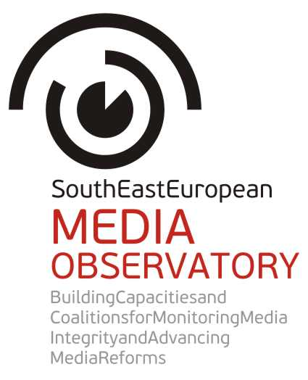 |  | 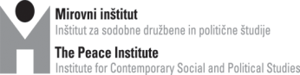
 |  | 
 |  | 
 |  | 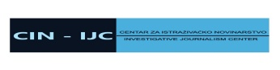
 |  | 
 |  | 
 |  | 

APPLICATION
FORM

FOR GRANTS
TO INVESTIGATIVE REPORTS
ON MEDIA IN SOUTH EAST EUROPE

Application deadline: 15 July 2013

Applicants are requested to provide the following data:

Applicant data:
1. Name of the applicant:
2. Status of the applicant (individual, NGO, media organization):
3. E-mail address:
4. Phone number:
5. If the applicant is an organization/institution, please provide the representative's name, title, phone number and e-mail address. Please also list the names of the team members who will be involved in the project:
6. Please attach a professional CV, resume or biography of the team members showing their experience in investigative reporting/data-journalism/research/multimedia skills.

Project description (max. 1000 words)
1. Title of the project (story idea)
2. Please describe the problem/corruption case you want to investigate.
3. How do you envisage to do the research?
4. How do you plan to illustrate the collected data (graphic, video, audio, etc.)?

Budget
All project expenses must be calculated in EUR. The budget narrative should describe the justification of the costs presented in the budget. For example, “Travel: EUR 100: transportation to cities in the countryside to do interviews for the story by 2 journalists; trip includes expenses for accommodation, meals.
Important:
Eligible costs are the expenses directly related to the production of the story. The purchase of any equipment is a non-eligible cost.
The budget should not exceed the maximum amount EUR 5000.
You can use the budget sample below and insert additional lines, if necessary. The budget can also be submitted in another file format (for example Excel), too.

Budget sample:
 | Costs | Unit | # of units | Unit rate  (in EUR) | Costs  (in EUR)
1 | Production/honorary fees
2 | Travel expenses
3 | Research and access to data services
4 | Translation costs
5 | Telecommunication expenses
6 | Office supply (printing/copying costs)
7 | Other costs (please identify the special expenses the project may include)
 | Total

Timeline
Please describe the expected dates of the process of the project implementation (research, interviews, data visualization, publishing, etc.) and the expected date of the completion.

References
Applicants must prove their professional capacities and therefore are required to submit three investigative articles (stories) published earlier on any subjects. They can attach scanned copies or provide existing links leading to these stories. Reference articles in local languages and/or English will be accepted.
Letter of intent
Please enclose a letter of intent from the publisher/editor-in-chief of the media organization interested in publishing the story.

South East European Media Observatory is a regional partnership of civil society organisations aimed at enhancing media freedom and pluralism, and influencing media reforms in the countries of South East Europe. It addresses obstacles to democratic development of media systems by providing a regional instrument for media research and monitoring, support to investigative journalism and civil society engagement. It also offers a regional framework for debates, consultations and coalitions among key stakeholders. SEE Media Observatory particularly addresses the problems with integrity of media and journalism in the region, focusing on harmful patterns of media ownership and media finances. In 2013 and 2014 the regional observatory concentrates on media integrity in Albania, Bosnia and Herzegovina, Croatia, Macedonia and Serbia. The partnership includes civil society organizations from two EU member neighbouring countries – Slovenia and Hungary, both with experience of media transition and ability to contribute to media reforms in the region by presenting lessons learned from successes and failures in democratic transition of media sector.
SEE Media Observatory is envisaged as a long term, continuous activity of the network of CSOs – South East European Network for Professionalization of the Media (SEENPM).

Coordinator of the Call for proposals for investigative reports on media in SEE Europe:
Center for Independent Journalism, Budapest, e-mail: seeapplications@cij.hu.

