Vukovar: a Life-Size Monument to the Dead City

Reduced to the “place of special reverence,” devoid of every form of life and serving as a depository of candles and wreaths, Vukovar - in the language of solemn matters – fell in vain.

by Boris Dežulović, Globus weekly news magazine, Croatia

(translation by Olga Vuković)
At that time, twenty or so years ago, the professional mourners lamenting over the dead body of Vukovar came up with the idea that the ruined town should be preserved intact for the future generations, as a museum city or a memorial park. In short, the idea was to turn Vukovar into a monument to itself.
The bizarre proposal was not an aberration coming from the margins. The enthusiastic advocates of the idea included certain very important figures of the time, among them professors, academics and the so-called patriotic intelligentsia, all of them going out of their way to outstrip each other in expressing ritual reverence for the sacrifice made by the Hero Town. How the “project” should have been carried out is still not completely clear although the idea was remarkably simple: everything in Vukovar was to be left intact, exactly as it was on the day when the “liberators” shot the fatally wounded town in the head.
The entire murdered city was to be conserved, possibly with the stabilization of ruins that could pose a threat for future visitors. The iconic bullet-scarred water tower, the mutilated Dunav Hotel, the flattened baroque city center, the burnt Eltz palace – everything was to be preserved as it was on “the day after,” that is, on November 19, 1991, possibly enclosed with a fence, in memory of that frightful autumn and as a warning for the future generations, “so that” – as the inscriptions in such cases usually read – “it may never happen again.”
Little thought was spared for the forty thousand people who had lived in Vukovar until that autumn. They would make it somehow, they would find the way to spring to their new lives from shelters and refugee camps – the people were definitely not thought of as a problem.
The most bizarre detail of the story is that at the same time the same idea emerged in Serbia. There were more than few proponents of the Monument Town in Belgrade and they pushed for the idea offering precisely the same justification – “so that it may never happen again.” And these were not anti-war activists but members of the ranks of Greater Serbia patriots.
The idea about the Memorial Town never came to life, though. It remained confined to the yellowing newspaper clippings. Or rather, it is what has been believed.
In reality, throughout the past two decades the patriotic architects painstakingly worked on the project and today the conservation of Vukovar is finally complete, its wartime image of the 1990s preserved and the town has become a monument to itself. Devoid of every urban, social and human meaning, today it is nothing but a life-size monument to the dead city, a monument to itself.
Vukovar simply does not exist beyond its symbolic function. It was probably in the late 1980s that the town’s newspapers last reported a news item that had no war connotations. Ever since then, every news story from Vukovar has had a war prefix, even if it was not directly connected with the war legacy. The rare flashes of social life in this town, for example the Vukovar Film Festival, are publicly significant – and therefore meaningful – only as improbable revelations of life in the dead town. In all other senses, these sporadic episodes of life in Vukovar that manage to elude the war context are inconsequential, or rather non-existent indeed. Just insidious subversions, bombs planted under the monument to the Hero Town.
A live Vukovar without the inscription “so that it may never happen again” does not exist on the map. Vukovar is one of the 15 largest towns in Croatia, but it has no basketball or football clubs: the Vukovar Football Team played in the Croatian premier league only one year – the year when the town was reintegrated into the Croatian constitutional and legal system and the club was catapulted to the top league by political decision, but only to drop out the following year, disappearing without a trace as soon as it fulfilled its ceremonial purpose.
There is no other purpose in Vukovar besides the ceremonial one. There are no painters or actors in Vukovar, no musical bands or rappers, no Vukovar starlets, designers or skaters, no Vukovar houses in real estate sections of the newspapers, no Pride parade, no sensational Vupik cabernet sauvignon, no odd balls from Vukovar on YouTube or Živa Istina reality show, no ceremonial ribbon cuttings, no big fish catches, no Guinness recorders, and even no tycoons or thieves, scandals or affairs, traffic accidents or armed robberies – nothing of this can be found in Vukovar devoid of Croatia-Serbia war background. In short, there is nothing in Vukovar.
Or rather, there is something – the Hero Town, the Homeland War, the Hawks, both senior and junior, the segregation in schools between Croatian and Serbian children, graffiti about Croats and Serbs, Cyrillic letters and bilingual street signs, demonstrations and memorial marches, flags and memorial masses, Chetniks and defenders, bishops, generals and the Headquarters for the Defense of Croatian Vukovar. Indeed, can anyone recollect the news item about Vukovar that did not mention the Headquarters for the Defense of Croatian Vukovar?
Twenty-two years later, Vukovar is just a conserved ruin of its former 1991 self, a preserved corpse, a depository of candles and wreaths without any purpose other than the protocolary reverence and the drilling of patriotism into people’s heads to which – fearing the symbolic power of the Hero Town – everyone acquiesces without asking unnecessary questions.
Not everyone will like this, but for such a symbolic Vukovar, profoundly lifeless and pointless and existing only in solemn words written in cheap Styrofoam, it is completely irrelevant who the winner of the Homeland War was. To the architects of the “memorial town,” the dead Vukovar would appear the same even if it remained occupied. It would be the same skeleton of the town and a monument to itself. The warning “so that it may never happen again” would also be the same, only written in Cyrillic.
As such, reduced to the mere “place of special reverence” and devoid of all forms of life, Vukovar – in the language of solemn matters – fell in vain. ●

Relevant context and additional information:
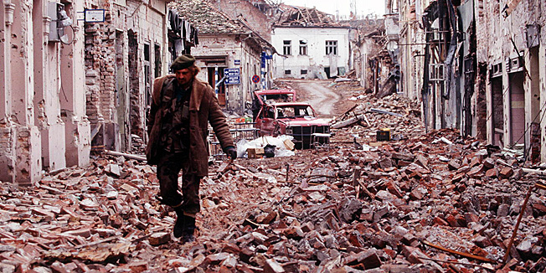
Vukovar, 1991
On Vukovar see also: http://en.wikipedia.org/wiki/Vukovar and http://en.wikipedia.org/wiki/Battle_of_Vukovar.

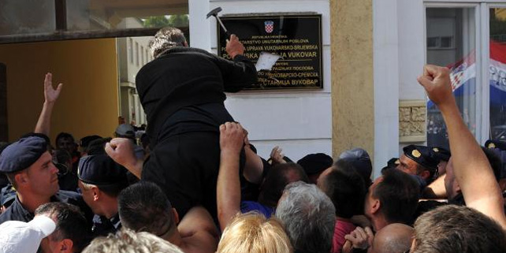
Vukovar, 2013, destruction of bilingual signs on the buildings of state authorities (to include names of institutions written also in Cyrillic).
See also http://www.balkaninsight.com/en/article/vukovar-bilingualism-introduce-faces-violent-resistance.

The column by Boris Dežulović “Vukovar: a Life-Size Monument to the Dead City” was first published in Globus, the Croatian weekly news magazine, within the regular section of Boris Dežulović's columns »Pact with the Devil«. (See: http://globus.jutarnji.hr/komentari/vukovar--spomenik-mrtvom-gradu-u-prirodnoj-velicini.)
It was published on 19 November 2013, the day after the annual commemoration of the fall of Vukovar. Few days later, as it is common practice with the Boris Dežulović's columns every week, it was widely reproduced by on-line media across the former Yugoslavia, including, for instance, the Serbian online media outlet Peščanik (see: http://pescanik.net/2013/11/ima-li-vukovara/; there is also a special section at that Belgrade based online media dedicated to Boris Dežulović's columns published in other media, see: http://pescanik.net/author/boris-dezulovic/) and by another Serbian online media outlet E-novine (see the reproduced column on Vukovar http://www.e-novine.com/stav/94361-Ima-Vukovara.html, and the section with Boris's columns from other media: http://www.e-novine.com/author/boris-dezulovic).
The column was also reproduced by Buka, the Bosnia and Herzegovina (Republika Srpska entity) based online media outlet (see the reproduced column http://www.6yka.com/novost/47267/boris-dezulovic-ima-li-vukovara, and the section devoted to Boris Dežulović's columns published in the print media across former Yugoslavia http://www.6yka.com/home/user_content/Qm9yaXMgRGXFvnVsb3ZpxIc=/boris-dezulovic) etc.

