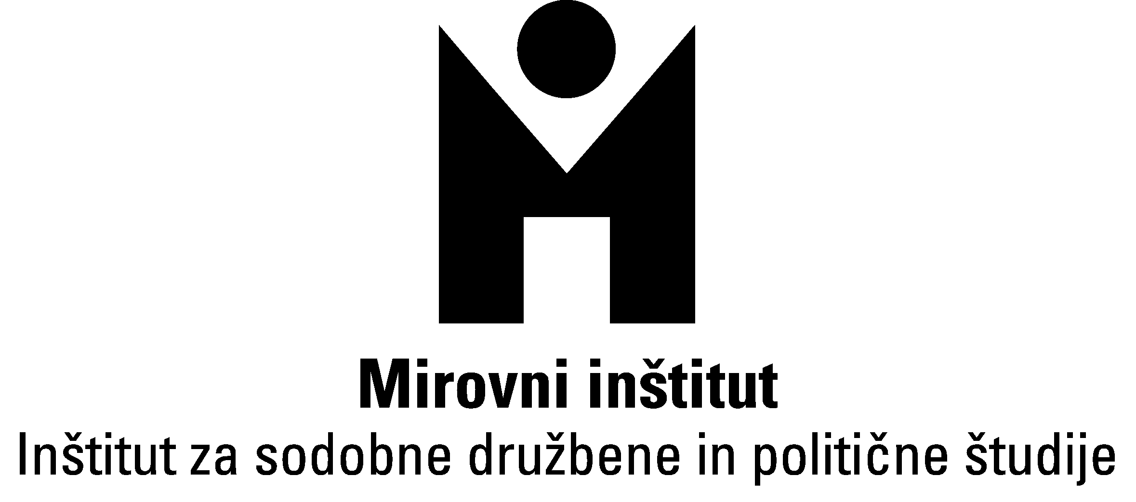 | 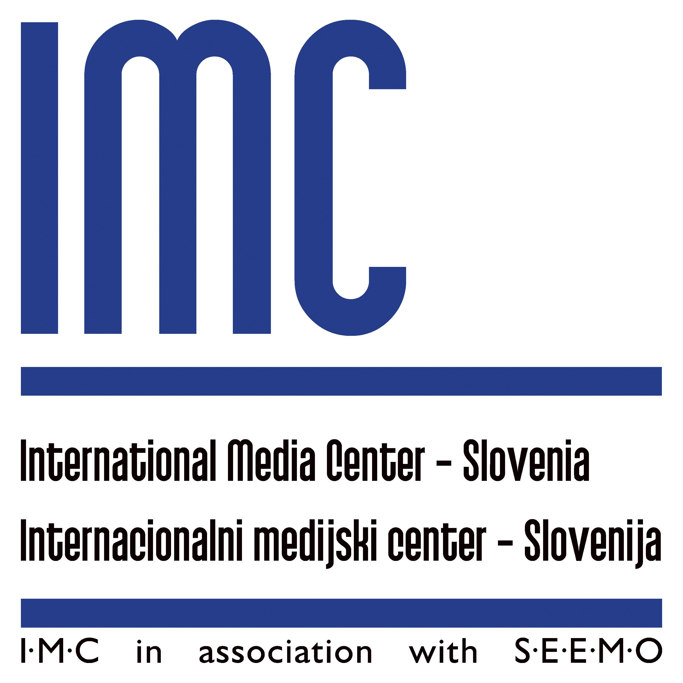 | Slovene Association of Journalists  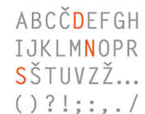
Letter of support to the Hungarian journalists and media community
in their efforts to protect media freedom and independence

Disputes over media regulation and claims of political control of the media – cases in Hungary, Slovenia and Croatia, differences and similarities was the title of the international round table in Ljubljana (Slovenia) on 29 March 2011, organized by the Peace Institute in Ljubljana, International Media Center IMC/SEEMO and the Association of Slovenian Journalists.

The round table and its panelists from Hungary, Croatia and Slovenia expressed great concern over the situation with media regulations in their own and other countries.

But it was especially the Hungarian media law which triggered debate on the need for stronger mechanisms for implementation and supervision of common European standards in the field of media freedom, pluralism and independence.

The panel in Ljubljana ended with the expression of support to the individuals and organizations in Hungary fighting for protection of media freedom and independence.

At the same time it concluded that the organizers shall continue to follow the developments regarding Hungarian media law and the initiatives of journalists in Hungary, and calls upon journalists in other countries as well as various European media institutions to become part of these initiatives aimed at application of best practices and standards in the field of media freedom, transparency, pluralism and independence in Europe, but also globally.

For more information please contact:
Mitja Meršol of IMC Ljubljana (mitjam@delo.si) or
Brankica Petković of the Peace Institute (brankica.petkovic@mirovni-institut.si).

Ljubljana, 7 April 2011

