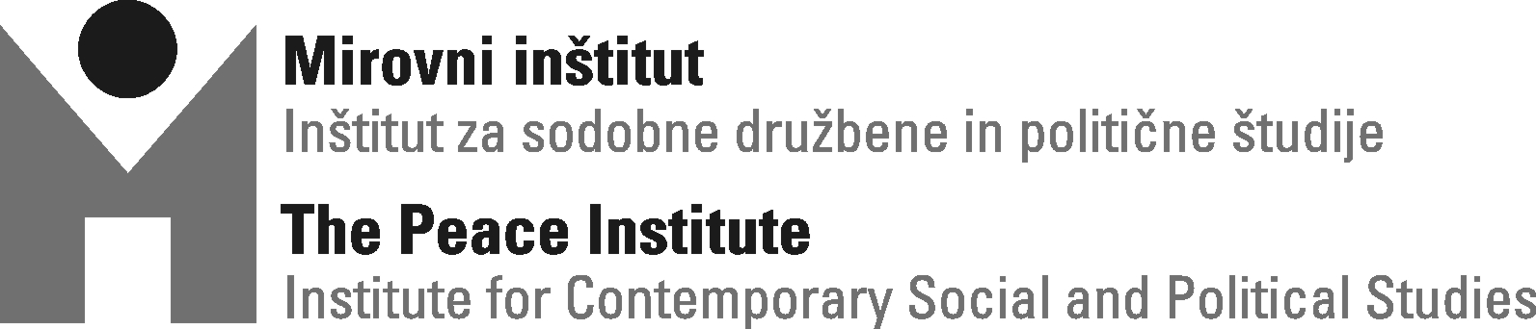

Conference

A Long Way Home – Media and Political Discourses
on the EU Integration of the »Western Balkans«

Ljubljana (Slovene Ethnographic Museum, Metelkova Str. 2)
Thursday, 26 November 2009
Within the framework of the OSI East East: Partnership Beyond Borders Program
Agenda

Thursday, 26. November 2009

10.00-11.00 Introduction: Media and Political Discourses on the »Western Balkans«
Speakers:
Tanja Petrović, ZRC SAZU, Ljubljana
Rastko Močnik, Faculty of Arts, University of Ljubljana

Chair:
Brankica Petković, Peace Institute, Ljubljana

      - Coffee break

11.30-13.00 New Colonialism
Panel discussion:
Mitja Velikonja, Faculty of Social Science, University of Ljubljana
Danijela Majstorović, University of Banja Luka
Boris Dežulović, Columnist for Globus, E-novine, Nezavisne novine and Dnevnik
Fatos Lubonja, Përpjekja, Tirana
Ervin Hladnik Milharčič, Journalist and Columnist for Dnevnik, Ljubljana

Chair:
Tanja Petrović, ZRC SAZU, Ljubljana

13.00-14.00 Lunch break

14.00-15.30 New Borders of Europe
Panel discussion:
Ivan Čolović, Institute of Ethnography, Serbian Academy of Arts and Science, Belgrade
Ugo Vlaisavljević, Faculty of Philosophy, Sarajevo
Lev Kreft, Peace Institute, Ljubljana
Andreas Pribersky, Institute for Political Science, Vienna University

Chair:
Brankica Petković, Peace Institute, Ljubljana

