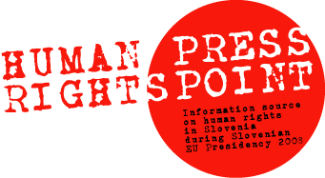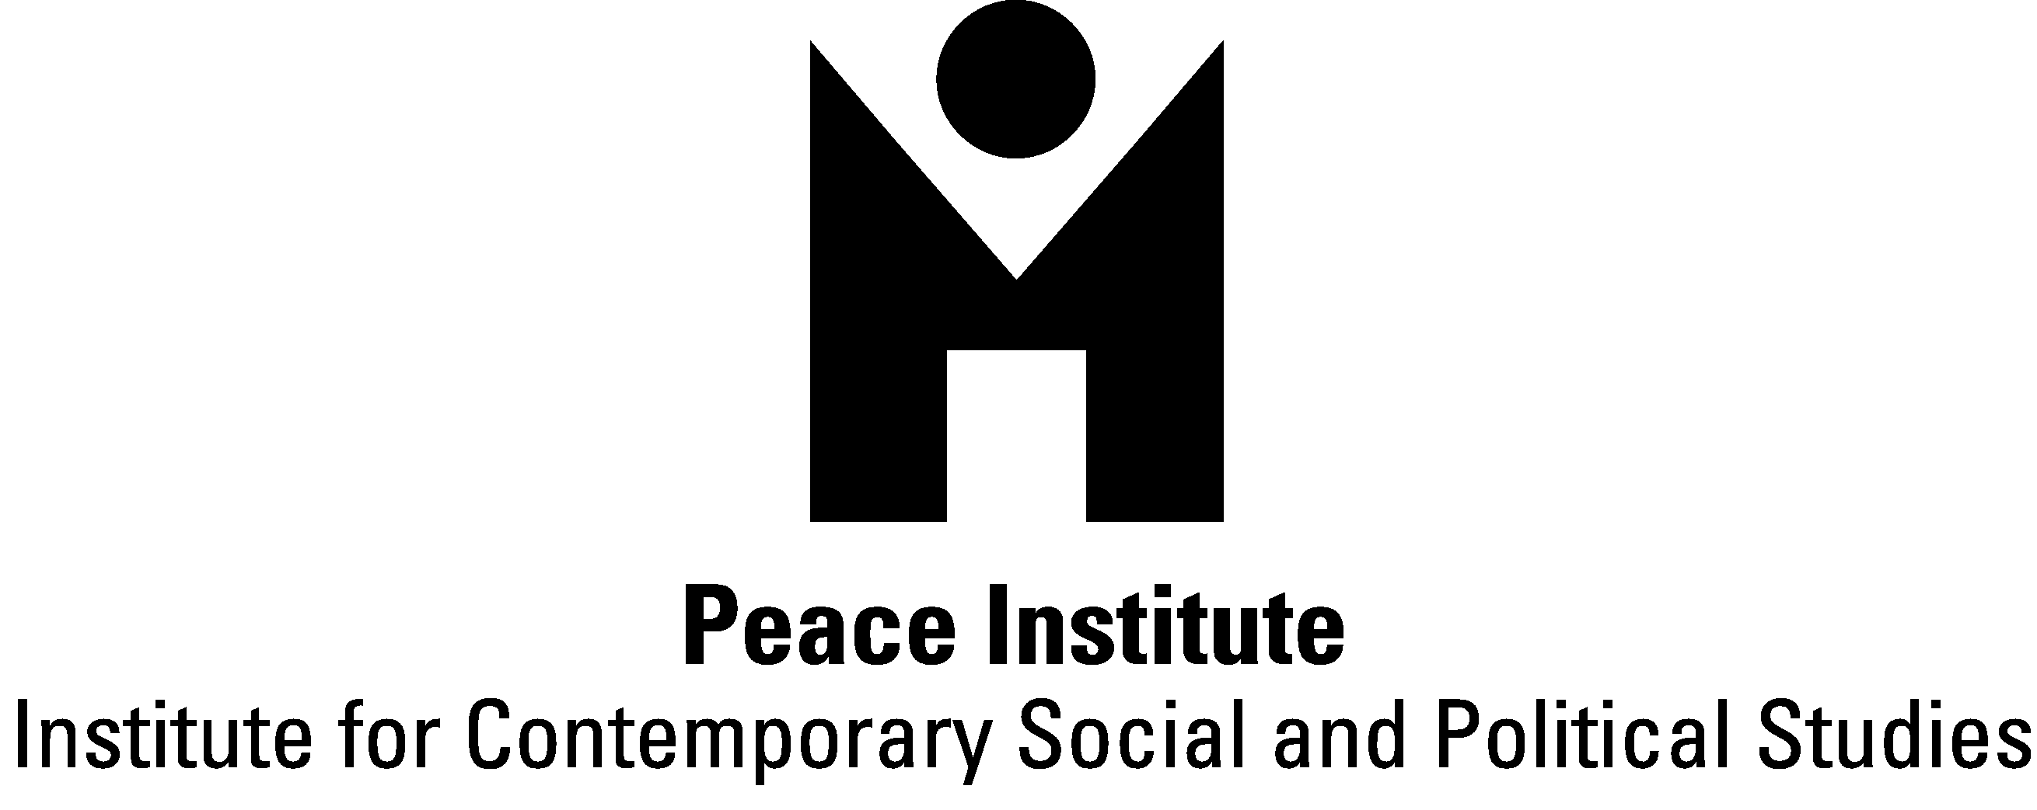

Dear,

We are pleased to inform you that the Peace Institute - Institute for Contemporary Social and Political Studies in Ljubljana has just launched the Human Rights Press Point – information platform for human rights situation in Slovenia, established to serve the interests of foreign journalists during the Slovenian EU Presidency 2008. It also provides useful information on human rights situation in the countries of the Western Balkans from the perspective of their EU integration.
Human Rights Press Point operates both as an internet portal and as an actual on-site press point in Ljubljana. You are free to use information either from our web site – www.humanrightspoint.si – or visit us on site at City Hotel (lobby, entrance 2 from Kolodvorska Street), Dalmatinova 15, SI-1000 Ljubljana.
Our main purpose is to contribute to visibility and understanding of human rights situation in Slovenia, and to a certain extent in the Western Balkans, by providing access to relevant sources - documents and people, primarily to those coming from civil society. In particular, the press point provides information and assistance regarding the following issues:
- Human Rights,
- Discrimination,
- Media Freedom,
- Erased Residents of Slovenia,
- Roma,
- Migration and Asylum and
- Western Balkans.
Relevant information, reports and documents, useful contacts and links on these topics with brief introductory summaries - all in English - are compiled in topical packages for journalists, which are available at our web site or in a printed version on site in City Hotel Ljubljana.
We are also available for assistance to journalists interested in human rights issues in Slovenia and in the Western Balkans in a form of identifying relevant sources and locations, primarily from civil society organizations and independent experts, citizens' groups and communities, including those whose human rights have been violated. We are available to assist journalists to arrange interviews and field trips to learn about human rights situation in Slovenia, and provide quality and reliable reports for their media and audiences.
During the Slovenian EU Presidency 2008, we will also organize three round table discussions on 1) Human rights situation in Slovenia, 2) Media freedom in Slovenia and 3) EU perspective of the countries of Western Balkans (the exact dates and venues are to be announced). The discussions will be simultaneously translated to English. At the same time, we will follow developments, needs and interests, being ready to organize ad hoc public events, such as press conferences, lectures, interviews etc. to advance discussion and raise attention to human rights issues during the EU Presidency in Slovenia.
Our goal is to use power and influence of various European and world media to achieve sensibility of the public and decision makers within relevant political bodies for improvement of human rights situation in Slovenia, and for EU prospects of the countries of the Western Balkans.
We work closely with other human rights organizations in Slovenia such as Amnesty International Slovenia (www.amnesty-international.si), Legal Information Centre for NGOs - PIC (www.pic.si) and Slovene Philanthropy (www.filantropija.org), as well as with Slovene Association of Journalists (www.novinar.com) and Trade Union of Slovene Journalists (www.novinar.com). We also cooperate with the Office of the Human Rights Ombudsman in Slovenia (www.varuh-rs.si). In the countries of the Western Balkans we cooperate with offices of the Open Society Institute (www.soros.org/about/foundations) and with human rights organizations in the region.
Human Rights Press Point project team are: Brankica Petković, Media Expert; Neža Kogovšek, Human Rights Expert and Lana Zdravković, Project Coordinator and web site Editor.
********
For more information please contact us by e-mail: info@humanrightspoint.si or by mobile phone: +386 31 735 186, contact person is Lana Zdravković.

