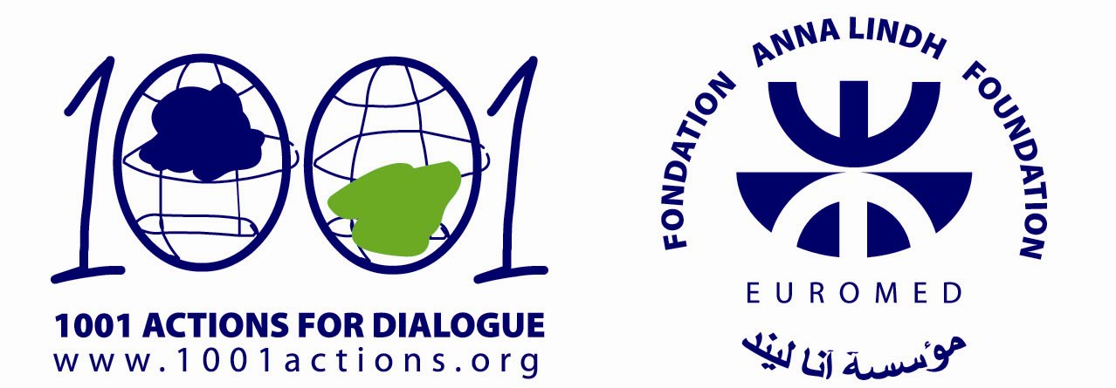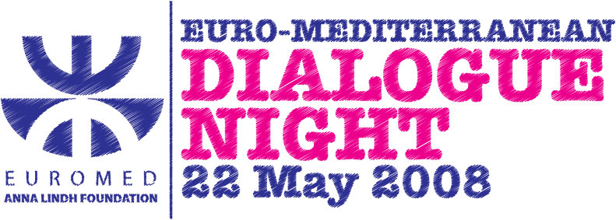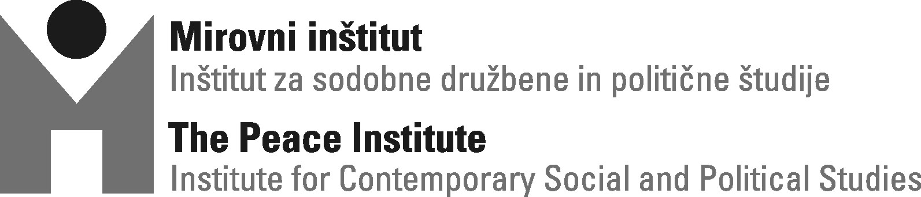

Program:

17.00 – Round table »Mediterrain: Dialogue or conflict?« (Klub Gromka)
Speakers: dr.Lev Kreft, dr. Nada Trunk Širca, dr. Klemen Klun, Janez Pirc, Zoran Potič.
20:00 – Kar češ brass band (yard in front of Klubom Gromka)
20:00 – Kulinarični kotiček (Schengen kichen, yard in front of Klub Gromka )
22:00 – concert Karavana iluzij / Illusion karavan (Klub Gromka)
funky-jazzy-etno style
24:00 – Haris Pilton DJ live act (Klub Gromka)
gipsy & balcan dub

17.00: Round table »Mediterrain: Dialogue or conflict?«
Nowdays first association regarding Mediterrain is in connection with culture – in general (mediterranean food or folk tradition) or high culture (italian painting, french literature, spanish dance…). Mediterrain today seems more as estethic-romantic chategory, as a piece of beauty and noble among industrialized, alienated, bureaucratized Europe.
However, this view on Mediterrain is not simple reflection of temporary state, but result of a long going history process. Since Antique untill 15th Century Medatirrain was manly area of economy battle. Rulling merchant sea paths was main competition advantage of Phenicians and reason for war between Greeks and Persians and Romans and Carthagens.
Mediterrain has stared to loose it's economic role with discovery of America and it's colonial outsoursing and offshoring, abuse of free indian and african labor force and import of american gold and silver. When their economic power melted, mediterranean countries started to trade with their cultural capital – and this is how Mediterrain has nowdays become place of turistic relaxation and cultural hedonism.
Dominant image of Mediterrain as cultural monument is not hidding only social history of this region – today in shadow of greek pillars and on the streets of eternal city class war is raging between inhabitants of south (african) an east (asian) part of Mediterrain on one side and inhabitants of north (european) part of Mediterrain on the other side. Second one is mostly part of EU and Schengen area, while first one belongs to devastated pheriphery – so main social-economic characheristics of Mediterrain are migration from south and east to north and represive EU migration policy. In background of historical contex of Mediterreraen region nowdays new economic-politcal and cultural-educational initiatives are emerching, which aim is to establish new sphere and regulation for columination of knowledge, capital and labour.

Speakers:
dr. Lev Kreft, director at Peace institute and professor at University of Ljubljana;
dr. Nada Trunk Širca, directress at Center EMUNI, Portorož;
dr. Klemen Klun, coordinator of intercultural studies at Center EMUNI and coordinator for intercultural dialogue at Ministry RS for Foreign Affairs;
Janez Pirc, fellowship researcher at Institute for Ethnic studies and member of African Center association;
Zoran Potič, journalist at daily newspaper Večer.
After presentations moderate debate will follow.

Večerni dogodek:

20.00: Kar češ brass band
Brass band from Cerkno plays since 1998 and has a great deal of concerts all over Slovenia among them on festivals as Rock Otočec, Ana Desetnica, Magdalena, Jazz Cerkno, Zmaj 'ma mlade, Koupa fest, Cmakajna and Vinska vigred. The group looks for inspiration mostly in street jazz of New Orleans, evergreen melodies of former Yugoslav republic and distilled products of home fruit.
http://www.karces.com/

Postava:
Marko Obid - tube
Sebastjan Jermol - trumpet
Tadej Bizjak – saxophone
Alen Bogataj – drums
Mitja Purgar – drums
Primož Podobnik - drums
Rok Šinkovec – tube
Florjan - trumpet

22.00: Karavana iluzij/Illusion Caravan
Karavana iluzij/Illusion Caravan is musical journey through pictures, memories and feelings. Members of bend are comming from different ethnic and cultural environments. They were gadered by need for expresion and exploring musical and personal experiences. Through their music and group energy we can hear and feel elements of swing, samba, bossa nova and funk in combination with rhythms of Eastern Balcan, origin region of music authoress and main force of the group, Jelena Milojević.
Some songs performed by llusion Caravan at Kultuar are part of project in progress »Gallery of music« by Cultuar weekend association and supported by Ministry of Culture and Municipaly of Ljubljana.

Postava:
Brigita Marko - vocal (Slovenia)
Petra Onderufova - violin, cello (Slovakia)
Aleksander Kuzmič – akustic guitar, vocal (Slovenia)
Damir Vintar - bass (Slovenia)
Đorđe Jeremić – drums (Serbia)
Marko Sikirica - percusions (Slovenia)
Jelena Milojević - guitar (Slovenia, Serbia)

24.00: Haris Pilton
Haris has been DJ-ing for years, but primarily he has been selecting and mixing dub and reggae music as a part of Positive Reality Soundsystem. In the last year or so, he has comited his musical creating to gipsy and balkan music. He didn't stop at just selecting it, but did a number of remixes, which have been very well received by slovene, austrian and croatian audience. His unique remixes & versions with lots of humour take a listener to the musical journey from Balkanistan to Radjestan, and even further on to Kingston town. Haris mixes traditional gipsy brass bands with urban beats & movie dialogues. You can constantly feel the big influence of reggae & dub music, which is logical considering Haris's a.k.a. High-I artistic roots. In less than a year, since he started DJ-ing his gipsy music sets, he has gathered a wide audience and his monthly parties in one of Ljubljana's clubs called Gromka has always been a success. Now he is weekly being invited to play by himself or with sampling and scratching support of DJ W. G. aka My Hell Jackson all over Slovenia.
http://www.myspace.com/harisdirtypilton

More informations regarding event and project:
Contact person: Jasna Babič, Peace institute
Telephone: 01/234 77 31
E-mail: jasna.babic@mirovni-institut.si.

Links:
http://www.euromedalex.org
http://www.1001actions.org
http://www.mirovni-institut.si
http://metelkova.org/gromka

This action is part of the regional campaign "1001 Actions for Dialogue" launched by the Anna Lindh Foundation the Dialogue between Cultures for the enhancement of peaceful coexistence and intercultural dialogue in the Euro-Mediterranean area. The action was generated with the financial support of the Anna Lindh Foundation.

