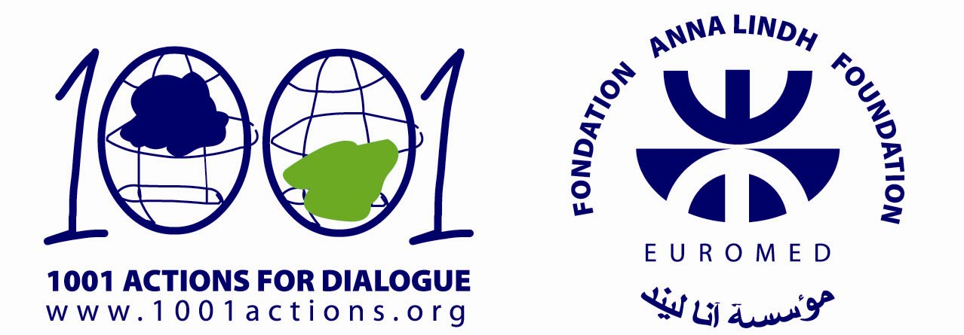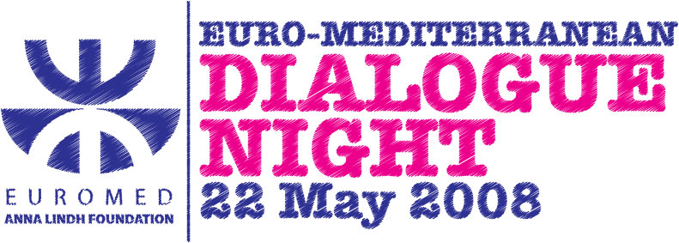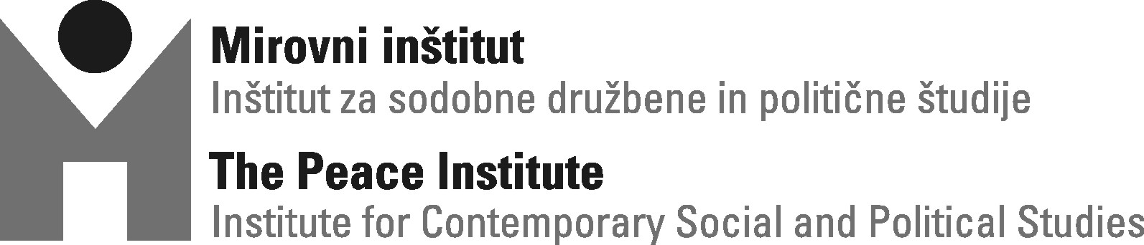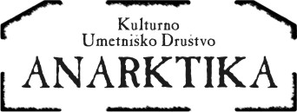

Dear all,

European Year of Intercultural Dialogue 2008 is based on the recognition of cultural diversity of Europe as its unique advantage. EU enlargement, deregulation of legislation of labour and globalization have enlarged multicultural character of many countries and contributed to increased numbers of languages, religious believes, national and cultural communities. Intercultural dialogue should contribute to the strength of the European identity and citizenship and strengthen the EU intercultural policies to its neighboring countries and worldwide. One of the initiatives and being one of the national members of the network Anna Lindh Euro – Mediterranean Foundation for the inter-cultural dialogue, we are organizing the »KULTUAR« event in May, with the aim to open different questions regarding Slovenia and the Euro – Mediterranean region.

The Anna Lindh Euro – Mediterranean Foundation (ALF), named after the Swedish minister who contributed to the establishment of the intercultural dialogue in Mediterranean, was founded during 2005 Barcelona conference, at the anniversary of the EU Mediterranean initiative also known as Barcelona Process. ALF acts as a network of 37 national networks of Euro – Mediterranean Partners (EU members and south Mediterranean coast countries) with the aim to promote regional cooperation in the field of education, research and art. The foundation’s headquarter is in Alexandria, the ancient port city in Egypt. The main purpose of the Foundation is to combine and encourage cooperation and overcome cultural differentiation in the mediterranean region by gaining the knowledge about the religious and social, political and cultural traditions which shaped this area as a crossroad of civilizations. The main objective of the Foundation is to fight racism and xenophobia as well as any form of discrimination, to challenge extremism from all sources and origins, to rediscover common roots and heritage of the Mediterranean area. Young people are their main target group. The most important part of ALF operation is a network of hundreds of non-government organizations and non-profit institutions from both sides of Mediterrain. Beside the UN, ALF is the only organization, in which both, Israel and the Palestine are taking part.

In 2008, a major campaign ‘1001 Actions’ is initiated by the Anna Lindh Euro-Mediterranean Foundation for the mobilization of people and actions dedicated to the promotion of mutual knowledge and respect in the region. Throughout the twelve months, actions for dialogue will take place across the Euro-Mediterranean region, from Morocco and Portugal to Lebanon and Turkey, from Latvia and Poland to Greece and Egypt. The key event of the campaign will be the Euro – Mediterranean Dialogue Night on 22 May 2008. The event, which will be held in simultaneously in thirty-seven countries, will be an opportunity for people of the Euro-Med region to unite in one common voice for dialogue.

The Peace institute, in cooperation with Cultural Association Anarktika, is organizing »KULTOAR« as part of Euro – Mediterranean Dialogue Night, on 22 May 2008 starting at 17.00 in/in front of Klub Gromka, Autonomous Cultural Centre Metelkova City, Ljubljana. The event will be divided in two parts; in the afternoon we are to hold a round table »the Mediterrain: Dialogue or conflict? «, during which we will open different questions regarding the Euro – Mediterranean region: artistic and cultural diversity, migration in past and present, temporary economic-political and cultural-educational initiatives regarding integration of Mediterranean area. In the evening, we shall pass the floor to musicians and they will be presenting their work, inspired by the diverse heritage of the Mediterranean and Central- European region and the Balkans.

Programme:

17.00 – Round table »Mediterrain: Dialogue or conflict? « (Klub Gromka)
20:00 – Kar češ brass band (yard in front of Klub Gromka)
20:00 – Cooking corner (Schengen kitchen, yard in front of Klub Gromka)
22:00 – concert Karavana iluzij / Illusion Caravan (Klub Gromka)
24:00 – Haris Pilton DJ live act (Klub Gromka)

For more information regarding the event and the project please contact:
Contact person: Jasna Babič, Peace institute
Telephone: 01/234 77 31
E-mail: jasna.babic@mirovni-institut.si.

Links:
http://www.euromedalex.org
http://www.1001actions.org
http://www.mirovni-institut.si
http://metelkova.org/gromka

This action is part of the regional campaign "1001 Actions for Dialogue" launched by the Anna Lindh Foundation the Dialogue between Cultures for the enhancement of peaceful coexistence and intercultural dialogue in the Euro-Mediterranean area. The action was generated with the financial support of the Anna Lindh Foundation.

Wellcome!

