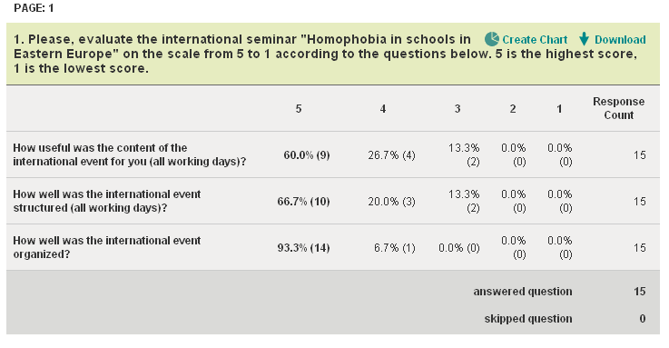
2. What did you like best at the international event?

- I'd like to emphasize the importance of reception before the seminar as the reception was a starting point for several conversations/contacts. It was also nice that many people took books, leaflets etc. with them to be shared. Also, the days were fully packed yet it was possible to see some Ljubljana, where I was for the first time.

- concrete examples from the field of education, including research findings

- Excellent outworked findings of social research, many well focused reports on experience (helpful!).

- Having a chance to discuss this topic with other participants

- Interesting presentations that gave me overview of what is happening in the region and socialising:-)

- I very much appreciated the opportunity to meet and have discussions with scholars from the region who are working on similar topics as me. I also liked Judith Stacey's participation, I think it's a good idea to have somebody who has done a lot of important work on our field but is from a different region of the world.

- Overview of LGBT education in schools id different European states

- It was interested for me to learn that quite a few theoreticians engage in activism and design/coordinate projects within different civil groups. In terms of the presentations, I found the research presented by Jasna Magic (Legebitra) most instructive, and the one presented by Rita Beres-Deak and Dorrotya Redai most useful for my future work.

- Panel discussion in the end.

- Timetable Speakers Venue Theme

- I liked the organization, the friendly environment, the free, open and interesting discussion.

- practical focus of papers, perfect organization

- The presence of Judith Stacey, the variety of the presentations and the high quality catering.

- International guest (Judith Stacey) + good organization

3. What did you miss?

- Cultural programme like one screening (Slovenian film/documentary) would have been very nice.

- more critical voices

- Theoretical reflections on findings of practice, esp. the bourgois ideas of parship, sexuality (e.g. on the background of former explicit non-bourgois policy) and of religiosity as hindrances in political, social and scientific work.

- More time to discuss

- I did not particularly miss anything, perhaps some time could have been allocated to discussion on possibilities of comparative and cooperative work.

- More time for non-formal discussions

- I would prefare more information from organization about their activities with children and in schools and less presentations of quantitative surveys with 100 participants and less.

- Nothing....it was perfect...the best conference ever!

- Nothing.

- in some papers i missed more detailed interpretation that would go behind the things that could be assumed beforehand

- -

- A bit more academic papers - but I understand that this is a very new topic in Eastern Europe.

4. What are your suggestions for improvement

- It would be great if speeches/presentations would start at 10 am, even if this would mean longer hours in the evening.

- keep up with a good work, start the sessions a liitle bit later, 10-11 am?

- Place for ad-hoc-workshops could help to reflect findings in groups structured by interest. Such important and big topics need more time: more than two days could had been filled.

- To leave more space to discuss

- It was a very fruitful and inspiring event for me. It would be good to have regular seminars (i.e every two years, for example) organized around the same topic, organized at different universities of the participating countries.

- N/A

- Conference proceedings would help disseminate materials to a wider audience.

- Different hotel. Maybe more structured discussions as was the concluding one.

- Organized again on similar theme!

- I have no suggestions.

- make people think of certain common concepts, theories or methodologies that then would make it easier to compare and discuss things.

- We could have started a bit later and have shorter lunch breaks.

- /

