 |  | 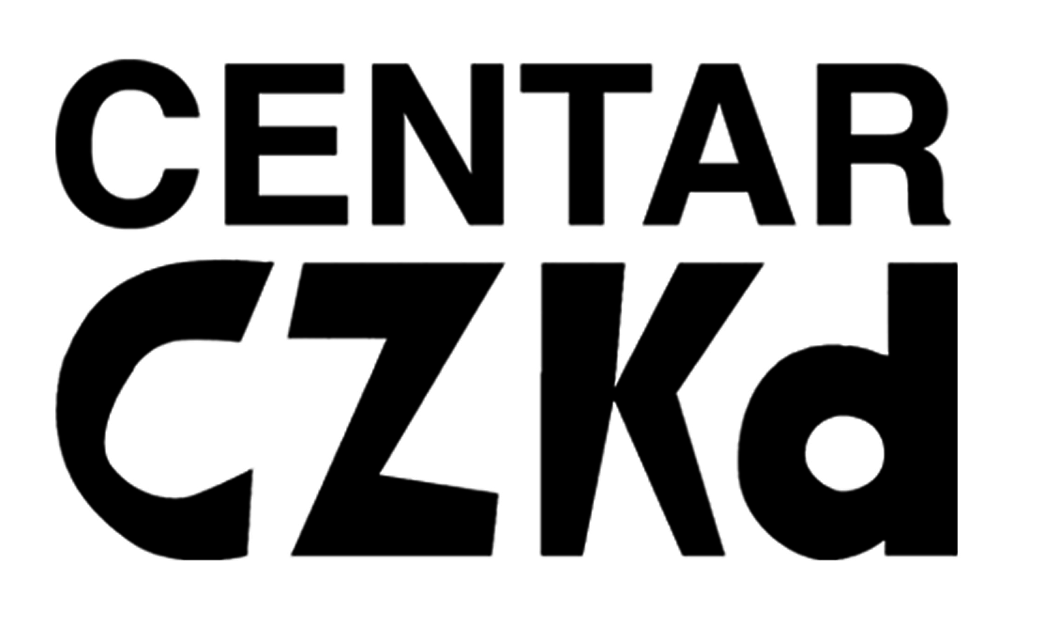 |  |  |  | 
This project is funded  by the European Union | Centre for Peace Studies  Pierottijeva 3/III  10 000 Zagreb  Croatia  Tel/Fax:  +385 1 4820 094  cms@zamir.net  www.cms.hr | Centar CZKD  Birčaninova 21  Beograd  Srbija  Tel/fax: +381 11) 2681-422  info@czkd.org  www.czkd.org | Human Rights Office  Boric 3  Tuzla, Bosnia and Herzegovina  Phone +387 35 250 504  Fax +387 35 360 491  Email: biroy@bih.net.ba  www.hrotuzla.org.ba |  | The Peace Institute Metelkova 6  Ljubljana Slovenia  Tel./Fax +386 234 7720  info@mirovni-institut.si  www.mirovni-institut.si

Regional Conference
MINORITIES FOR MINORITIES: GOOD PRACTICIES EXAMPLES IN INTERETHNIC RELATIONS

14th and 15th April 2010, Zagreb, Croatia

The Conference is held under the patronage of the president of the Republic of Croatia, Mr. Ivo Josipović

I. DAY |  | II. DAY
 | Topic/Speaker |  | Topic/Speaker
9:00-10:00 | Registration of participants | 9:00-10:00 | Introduction: division of participants into national teams
10:00-11:00 | Welcome/introduction to the Conference by President of Republic of Croatia, other high governmental representatives and Project partners | 10:00-11:30 | Groups’ discussions: “Detection of gaps in national legislative frame for national minority protection”- presentation of expert papers and drawing conclusions
11:00-12:00 | Presentation of the international and EU standards in minority’ rights protection/ Peace Institute Slovenia and representatives of European Commission in Croatia | 11:30-11:50 | Coffee break
12:00-12:20 | Coffee break | 11:50-13:30 | Division of participants into professional teams (1 group: minority representatives and state officials, 2nd group: NGOs and experts) Group discussions: “Common agenda of minority representatives and potential for joint advocacy”
12:20:13:30 | Presentation of the current state of minority rights in ex-Yu States | 13:30-15:00 | Lunch break
13:30-15:00 | Lunch break | 15:00-16:30 | National teams discussions: “Potential of using good practice examples for its implementation on the national level”- drawing action plans for implementation and advocacy actions
15:00-17:00 | Presentations of good practices by community representatives | 16:30-17:00 | Coffee break
17:00-18:00 | Discussion | 17:00-19:30 | Presentation of conclusions and Action plans
18:00- 19:00 | Presentation of the book on good practices | 19:30-20:30 | Presentation of Conference follow up activities
 |  | 20:30 | Farewell diner

