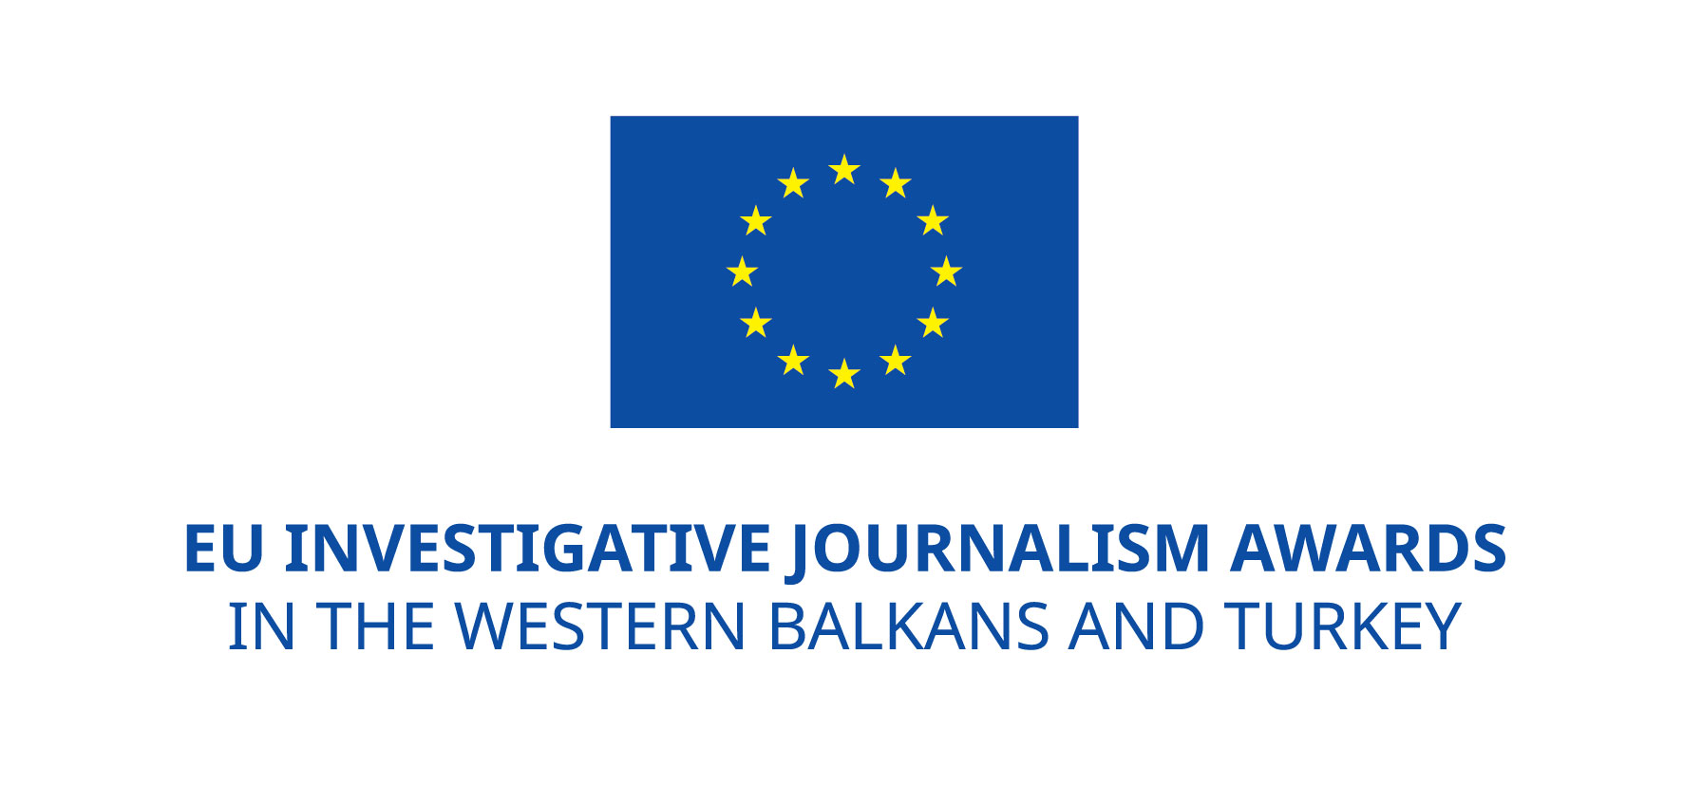
Regional EU award scheme for investigative journalism in Western Balkans and Turkey launched

The regional scheme of EU awards for investigative journalism in Western Balkans and Turkey has been launched in March 2015 aiming at celebrating and promoting outstanding achievements of investigative journalists and improving the visibility of quality investigative journalism in the region.
Within the regional scheme, seven separate award contests are being organised in Albania, Bosnia and Herzegovina, Kosovo, Macedonia, Montenegro, Serbia and Turkey.

On 16 and 17 March 2015, the contests for EU award for investigative journalism were launched in in Kosovo, Albania and Montenegro. The award launching events were organised in the EU Information Centers. EU Special Representative in Kosovo Mr. Samuel Žbogar, Head of Political, Economic and Information Section at the EU Delegation in Albania Mr. Clive Rumbold, and Head of the EU Delegation in Montenegro Ambassador Mitja Drobnič announced the award contests (see the pictures below). On 24 March 2015, the contests will be launched in Macedonia and Bosnia and Herzegovina. In Serbia and Turkey, the launch of the award contests is expected by the end of March.

The EU award regional scheme for investigative journalism in Western Balkans and Turkey is established by the European Commission, DG Enlargement, following the EU Enlargement strategy which recognizes strong need for ensuring freedom of expression in the media, and for support to investigative journalism to monitor the reform processes and to keep the historical momentum toward the EU accession.

Seven countries, three years, 210,000 EUR award fund
The EU award for investigative journalism will be given each year in the period of three years in each of seven EU-Enlargement countries: Albania, Bosnia and Herzegovina, Kosovo, Macedonia, Montenegro, Serbia and Turkey, rewarding the investigative journalistic work published in 2014, 2015 and 2016.

Investigative stories contributing to transparency and reporting on societal issues related to abuse of power and fundamental rights, corruption and organised crime that otherwise would not have been brought to the public's attention will qualify for the award.

The award fund for seven beneficiary countries for three years in total is 210,000 euro. Annual award fund for each country is 10,000 euro; 1-3 journalists shall be awarded in each country each year; 3000- 5000 euro per individual prize is to be awarded.

The selection of the award winners in each country will be done by independent juries based on the common selection and award criteria such as relevance of the investigative story, quality, originality and journalist’s professional commitment and integrity. If necessary, additional criteria of impact will be also taken into consideration.

The EU award regional scheme administration
The award scheme is administered by the regional partnership of civil society organisations, coordinated by the Peace Institute in Ljubljana, Slovenia, which was selected for that task by the European Commission:
- Albanian Media Institute (AMI), Tirana, Albania
- Media and Civil Society Foundation Mediacentar Sarajevo (MCF), Sarajevo, Bosnia and Herzegovina
- Kosovo Press Council Kosovo (KPC), Pristina, Kosovo
- Macedonian Institute for Media (MIM), Skopje, Macedonia
- Montenegro Media Institute (MMI), Podgorica, Montenegro
- Novi Sad School of Journalism (NSSJ), Novi Sad, Serbia
- Platform24 (P24), Istanbul, Turkey
Associate partner is The Guardian Foundation, London, United Kingdom.
The partners administering the EU awards for investigative journalism are the same as those implementing the Phase 2 of the regional project “South East European Media Observatory – Building Capacities and Coalitions for Monitoring Media Integrity and Advancing Media Reforms”.
The European Commission has approved the selection criteria for the award, and EU Delegations have been approving the juries in each country. Main steps in the award contest preparations, launching and implementation are also coordinated with the European Commission and EU Delegations.
In cooperation with The Guardian Foundation the best investigative story in the region will be selected from the winners of the seven country contests. The author will be invited to a study visit to The Guardian/Observer.

Information about the EU award contests
Detailed announcements of the EU award contest, instructions for submission of nominations and nomination/entry forms will be available on the web sites of the partner organisations in each respective country on the day of the launch of the EU award contest in each of them.
The contest is open in each country for one month, the award ceremonies are expected in each country in June 2015.
For additional information about the regional scheme please contact the regional project coordinator Brankica Petković at brankica.petkovic@mirovni-institut.si, and for national award contest visit the web sites of the project partners in each EU-enlargement country.
Photos:
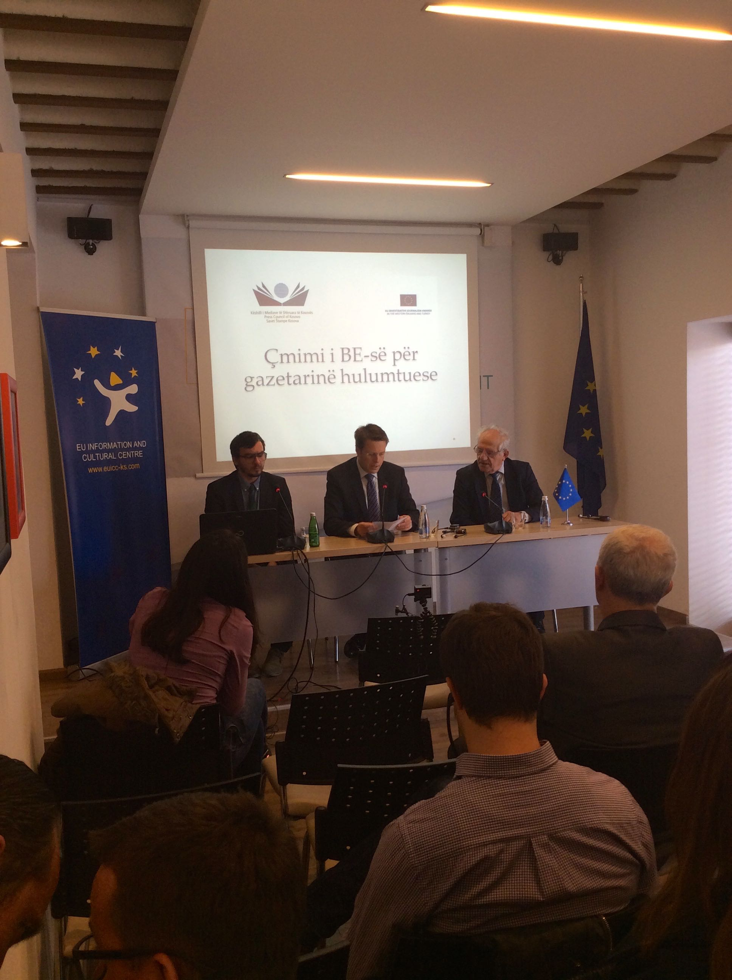 Priština, 16 March 2015: EU award for investigative journalism launching event | 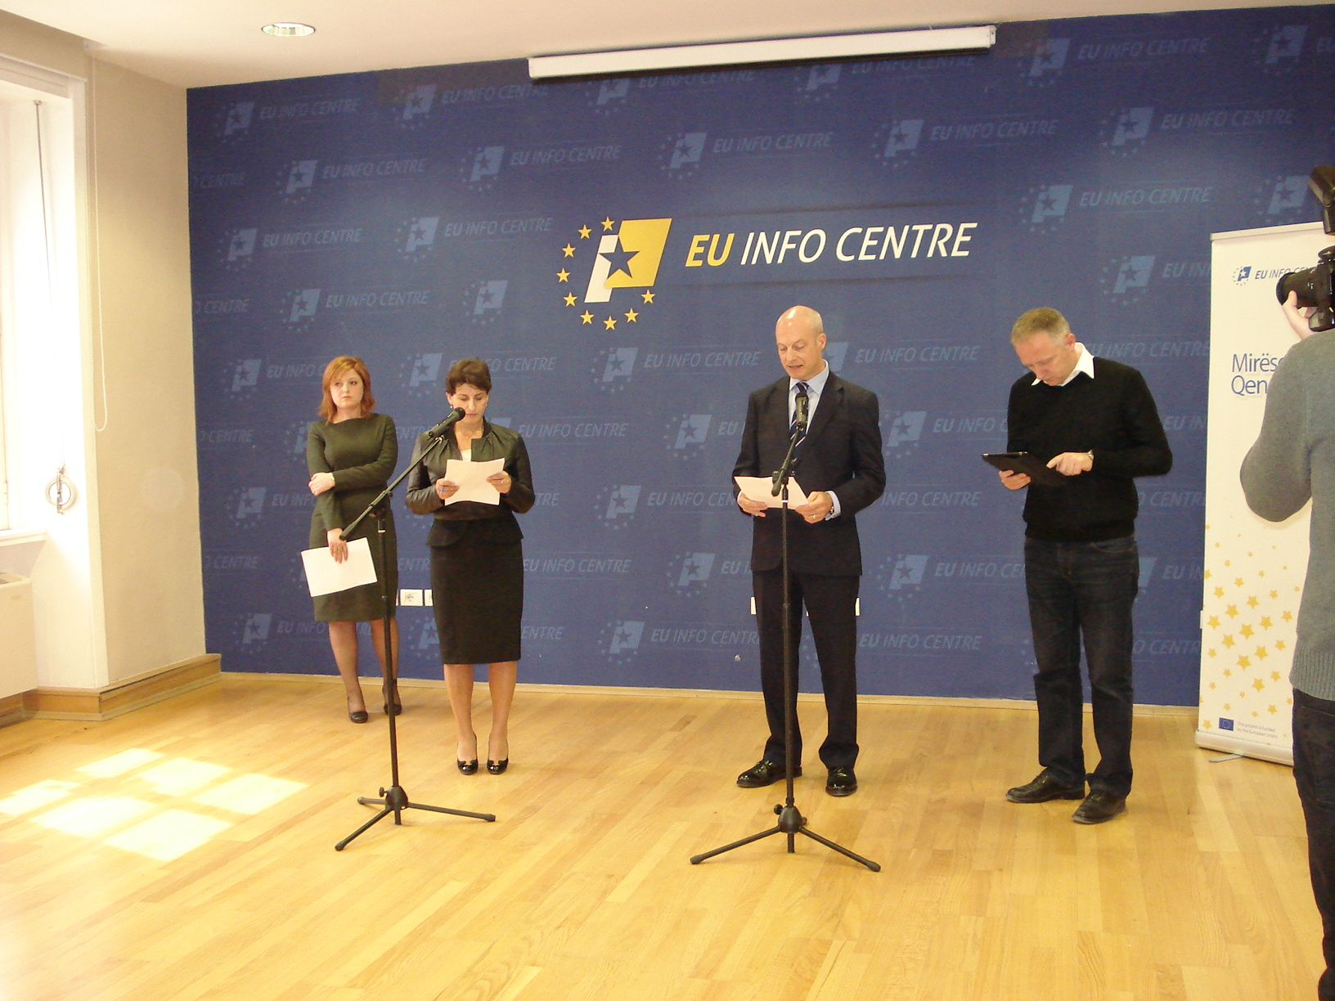  Tirana, 17 March 2015: EU award for investigative journalism launching event  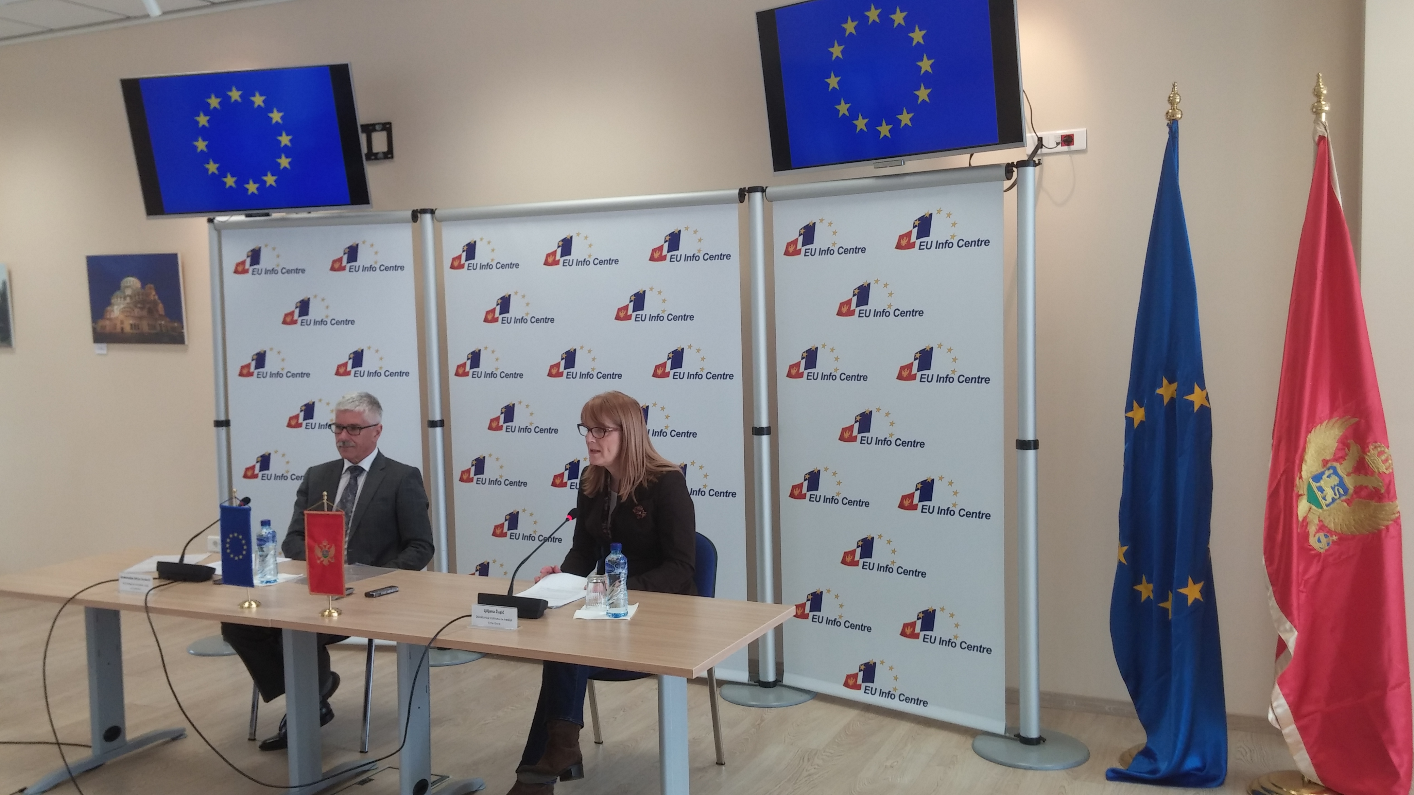  Podgorica, 17 March 2015: EU award for investigative journalism launching event

